**SYNC YOUR MICROSOFT SQL DATA TO ELASTICSEARCH USING LOGSTASH**

***We will learn how to sync your Microsoft Sql data to Elasticsearch 7.x. How to schedule and update them with zero effort***

|  |
| --- |
| **AIMS:**   * Logstash configuration to sync Microsoft Sql data * How to build on purpose docker image * Include plugins in docker image |

**SUMMARY**

In many years our search perception change. Now google search or another search bar in everywhere. You can see your in phone or you can see on computers etc. So many developer needs searches and they have to do it fast. In traditional for searches in Microsoft Sql we can write queries work on small data set but what about in big datasets? You can choose, change queries and their performance and you can replicate your server etc. But this would be bad solution in my opinion but why? Because Microsoft Sql have many tasks, insert data, update data, delete data etc. Of course, it was created for this but you can separate your search from database and you can give that responsibility to another. I mean you can give that job to who is job do search.

Contents

**WHAT IS MICROSOFT SQL** 3

**WHAT IS ELASTICSEARCH** 3

**WHAT IS LOGSTASH** 4

**WHAT IS DOCKER** 4

**IN ACTION** 4

**My Own Test Environment** 5

**Docker Setup** 5

**Windows** 6

**Ubuntu** 6

**Install Microsoft SQL Server on docker** 6

**Install Elasticseach on docker** 8

**What you need for logstash** 9

**Build docker image with logstash plugin** 9

**Create docker compose file for logstash container** 11

**Logstash configuration file** 13

**RESULTS** 15

**WHAT IS MICROSOFT SQL**

**Microsoft SQL Server is a relational database management system (RDBMS)** that supports a wide variety of transaction processing, business intelligence and analytics applications in corporate IT environments**. Microsoft SQL Server is one of the three market-leading database technologies**, along with Oracle Database and IBM's DB2. (Rouse, 2019)

Like other RDBMS software, Microsoft SQL Server is built on top of SQL, a standardized programming language that database administrators (DBAs) and other IT professionals use to manage databases and query the data they contain. SQL Server is tied to Transact-SQL (T-SQL), an implementation of SQL from Microsoft that adds a set of proprietary programming extensions to the standard language. (Rouse, 2019)

**WHAT IS ELASTICSEARCH**

Elasticsearch is a **distributed, open source search and analytics engine** for all types of data, including textual, numerical, geospatial, structured, and unstructured. Elasticsearch is built on Apache Lucene and was first released in 2010 by Elasticsearch N.V. (now known as Elastic). Known for its **simple REST APIs, distributed nature, speed, and scalability**, Elasticsearch is the central component of the **Elastic Stack, a set of open source tools for data ingestion, enrichment, storage, analysis, and visualization**. Commonly referred to as **the ELK Stack (after Elasticsearch, Logstash, and Kibana),** the Elastic Stack now includes a rich collection of lightweight shipping agents known as Beats for sending data to Elasticsearch. (Elasticsearch, 2019)

**WHAT IS LOGSTASH**

Logstash is an **open source, server-side data processing pipeline** that ingests data from a multitude of sources simultaneously, transforms it, and then sends it to your favorite "stash." (Elasticsearch, 2019)

**WHAT IS DOCKER**

**Docker is a tool designed to make it easier to create, deploy, and run applications by using containers**. Containers allow a developer to package up an application with all of the parts it needs, such as libraries and other dependencies, and ship it all out as one package. By doing so, thanks to the container, the developer can rest assured that the application will run on any other Linux machine **(Now they can run Windows machine too and windows containers released)** regardless of any customized settings that machine might have that could differ from the machine used for writing and testing the code. (Opensource, 2019)

**In a way, Docker is a bit like a virtual machine. But unlike a virtual machine, rather than creating a whole virtual operating system, Docker allows applications to use the same Linux kernel as the system that they're running on and only requires applications be shipped with things not already running on the host computer. This gives a significant performance boost and reduces the size of the application.** (Opensource, 2019)

And importantly, Docker is open source. This means that anyone can contribute to Docker and extend it to meet their own needs if they need additional features that aren't available out of the box.

(Opensource, 2019)

**IN ACTION**

Now we can take a action for our scenario. First, we need environment, **you need Elasticsearch, Microsoft SQL server and Logstash.** I used **docker** for this environment but if you already have, you can skip these sections:

* Docker setup
* Windows
* Linux
* MacOs
* Install Microsoft SQL Server on Docker
* Install Elasticsearch on docker
* What you need for logstash
* Build docker image with logstash plugin

**My Own Test Environment**

My environment is running on Windows with Docker Desktop

*Windows version is:*

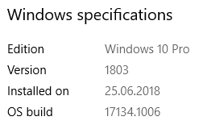

*Docker Desktop version is:*

Docker Desktop Community 2.1.0.3

*Docker version is:*

Docker version 19.03.2, build 6a30dfc

We will use logstash and elasticsearch so their version is:

*elasticsearch:7.3.0*

*logstash:7.3.1*

**Docker Setup**

I use docker for this so if you don’t have, I will try to explain installation. Windows part is easy, you can maybe face some challenge but you can do it. Ubuntu part is quite more easy than windows, you will see it. MacOS part… I don’t know, I have never a Mac ☹ Mac have Docker desktop too, so it seems easy as Windows

**Windows**

First of all, go to link <https://www.docker.com/products/docker-desktop> you will see download Docker Desktop Mac or Windows click it. You will see login screen, **you need docker account for download**. You can register here <https://hub.docker.com/signup> and then do the same steps, come login screen, login to system and you will see “**Download Docker Desktop for Windows**” button click and download it.

While installing program you can maybe face it **HYPER-V not enabled problem** Go to your **BIOS settings** and **enable HYPER-V** and then try to install setup again. If you have more trouble please go to this link and read <https://docs.docker.com/docker-for-windows/install/>

**Ubuntu**

Ubuntu part is easier than Windows. My ubuntu version is 18.04 first of all open command prompt and write these step by step:

sudo apt-**get** update

sudo apt-**get** remove docker docker-engine docker.io

sudo apt install docker.io

sudo systemctl start docker

sudo systemctl enable docker

And you can check your installation with

docker --version

You will see something like this (Simic, 2018)

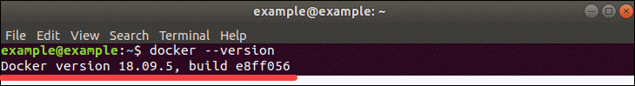

**Install Microsoft SQL Server on docker**

Yes, you can run your sql server in docker container. This is good you can skip all sql server setup cause you want only development now, if you in production you can think about it but you want it development NOW!

**So open your command prompts and write docker command**

docker run -e --name dmssql “ACCEPT_EULA=Y” -e “SA_PASSWORD=<StrongPassword>” -p 1433:1433 -d mcr.microsoft.com/mssql/server:2017-CU8-ubuntu

**Once you should be careful about <StrongPassword> area you have to choose right password for microsoft password policy**. If you don’t have strong password on your mind, just use <https://passwordsgenerator.net>

In container creation process first you have to download image, **this operation handled automatically by docker(pull operation).** You should see something like this.

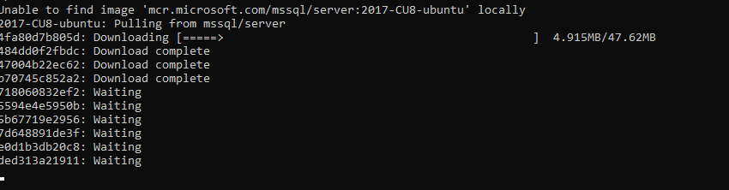

When download process is done, you can look container logs **for detect Microsoft Sql Server start properly**. You can use this command:

docker container logs <container-name or id>

**If you don’t know your container name or id** you can look them use this command:

docker container ps



You should see something like this row. **If you don’t see mssql. You can look all containers properly start or not:**

docker container ps -a

**Now you can see mssql row. If you don’t see in “docker container ps” command, your container probably not start properly and crash.** You can look logs for what is going wrong inside.

If your mssql started properly which you see container in “docker container ps” command, you will see in logs something like this row. If you see, **you started mssql server successfully**



Then you can log in inside use Sql Server Management Studio.

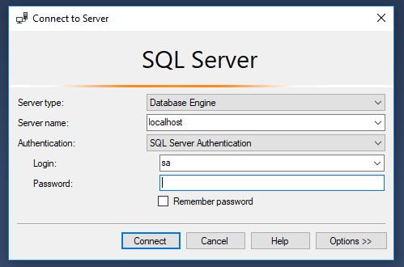

You have to write your strong password in Password area. You can change your password after login 😊

**Install Elasticseach on docker**

**Let’s up and run our elasticsearch on docker.** You will need this docker command line for this action:

docker run --name els -p 9201:9200 -p 9301:9300 -e "discovery.type=single-node" docker.elastic.co/elasticsearch/elasticsearch:7.3.0

**You will see pulling image screen again like previous steps** (You can look “**Install Microsoft SQL Server on docker**” section) And if you look containers logs again you have to see something like row:



Again, if you **don’t remember how you can look logs of containers**, you can look previous step for inspect logs (You can look “**Install Microsoft SQL Server on docker**” section)

**What you need for logstash**

We need **synchronize our Microsoft SQL Server data to Elasticsearch**, we search in the internet and we find logstash app. If you run logstash, i mean pure logstash, **have no capability transform MSSQL data to Elasticsearch**. We **need plugin for that** and we **have to install in our logstash image.** So we need to build a docker image. We need only **“logstash-input-jdbc”** plugin for this operation but I will install few more plugins:

* logstash-filter-jdbc_streaming
* logstash-filter-aggregate
* logstash-input-jdbc
* logstash-filter-translate

**logstash-filter-jdbc_streaming:** This guy taking you sql results and **keep in temporary cache** (Elasticsearch, 2019)

**logstash-filter-aggregate:** If you have multiple events on several entities, this plugin **can take them and push aggerated results one event** (Elasticsearch, 2019)

**logstash-filter-translate:** This plugin is general search and replace tool, looking columns find values, replace and put in destination columns in Elasticsearch (Elasticsearch, 2019)

**logstash-input-jdbc:** This is our plugin to transform sql data to Elasticsearch. **This plugin is designed for get data any database with JDBC interface**. (Elasticsearch, 2019)

We will use mainly logstash-input-jdbc plugin. This guy **need driver for connect to sql servers** (oracle, mssql, mysql, postgresql). We have **to download jdbc driver for him**. I create folder which name is jars and put drivers in that folder. I use **“mssql-jdbc-7.4.1.jre8”** driver for connect Microsoft SQL Server. You can download directly these drivers from <https://github.com/microsoft/mssql-jdbc/releases> address. If you download driver, now we can go to next step.

**Build docker image with logstash plugin**

First you **can create a folder with name “logstash**”, than inside that folder **create another folder and give name that folder to “jars”** Then **create a file, this file name have to be “Dockerfile”**, you **don’t need an extension for this file** so name it. After that you have seen something like this:

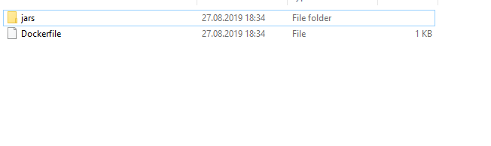

**Now open Dockerfile using any text editor and start writing.**

FROM docker.elastic.co/logstash/logstash:7.3.1

RUN logstash-plugin install logstash-filter-jdbc_streaming

RUN logstash-plugin install logstash-filter-aggregate

RUN logstash-plugin install logstash-input-jdbc

RUN logstash-plugin install logstash-filter-translate

COPY ./jars /usr/share/logstash/logstash-core/lib/jars

Let’s explain line by line. First line, say docker to which image we are using for build our image, we use **“FROM”** command for this in docker World. After that we use **“RUN”** command for execute to something inside container. In next four line we are installing our plugins which we mentioned in previous section. Last line we are copy our jars folder content to inside Logstash container image, which our jdbc plugin use for later to connect our Microsoft SQL Server. You can put that folder more than one jars if you want multiple data streams.

After that explanation we have to build our image. We have to write docker command for this situation. Let’s do that. Go to Logstash folder in command prompt and write:

docker build -t logstash-with-mssql-plugin:1.7 .

You have to be careful in writing command process, last character should be dot(.) with spacebar separate. If you do that successfully you should see something like this

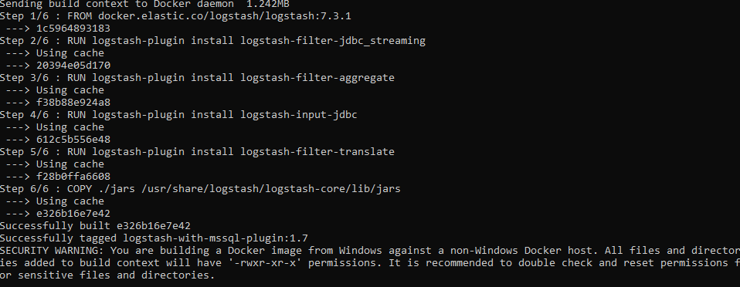

In command -t means tag and this is our image name actually. This info will be usefully for when we are creating compose file just keep that your mind 😊

**Create docker compose file for logstash container**

Now we come Logstash container creation process. This can be done using by docker run command but this will be long command. So, we need to see big picture, so we need something like code file. You can use that for docker-compose, let's get our hands dirty! **Create logstash-compose.yml file in our “logstash” folder.**

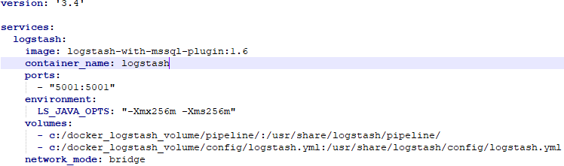

I give that as image because my code not fitting good in word, **don’t worry you can access that codes in my GitHub account repository.** I will give you address end of the article. Let’s explain this code.

Version number tells that which compose version will be using this compose file. **You can access their differences** from <https://docs.docker.com/compose/compose-file/compose-versioning/>

In services section we are writing our container specs. We are giving service name first which represent as “logstash:” and then step in code for select image to our containers, you can see in our builder image on this section, I am talking about this section “image: logstash-with-mssql-plugin:1.6” Then we can give container_name our container for easy find in docker network. In docker world container name represent as hostname like [www.google.com](http://www.google.com) and access that container from another container, you can use this container_name like hostname.

Of course, we need expose our ports for accessing Logstash from host computer. You can use for this purpose “ports” command in compose file. In environment section we can pass special configuration parameters to container. This can be different for every docker image also some image doesn’t need env variable too, so why we use this environment variable in our compose file. When Logstash start need initial heap in memory. You can set these options using LS_JAVA_OPTS variable. You can see detailed explanation in here <https://www.elastic.co/guide/en/elasticsearch/reference/current/jvm-options.html>

Now we are in volume section, this section is critical because we need access some things inside container also need somethings persist (data config etc.) We can use volume section to share data, config etc. between host computer and container. If you in windows you can share your drive inside docker, go to settings-🡪Shared Drivers section and choose your drive.

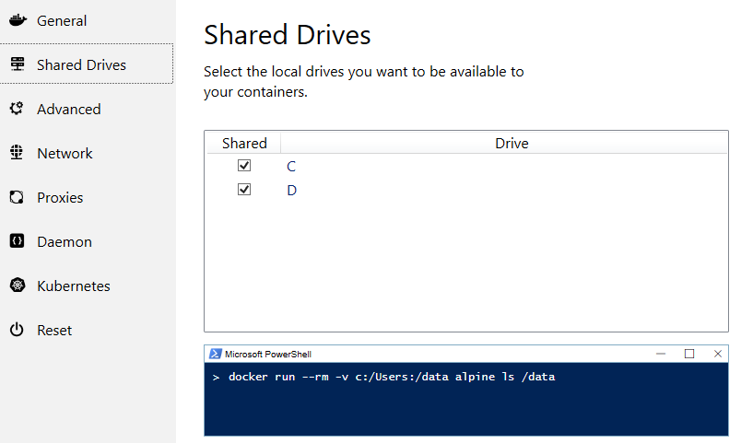

After that explanations now volume section has to be clearer to you. In Logstash container system I believe we should share two section. First is pipeline section which is critical for our data transformation to Elasticsearch, we will put Logstash.config file in here, we will see config file next section 😊 Second one is main config file logstash.yml, not need for this scenario but later more complex scenarios you can be need that file.

Last code is network_mode section, this is critical because we have two other container mssql and elasticseach. We have to communicate these containers so need in bridge network, because docker run command create container in bridge network. Now let’s run our compose file. In command prompt come in “logstash” folder.

docker-compose -f logstash-compose.yml up -d

After you have to see something like this:

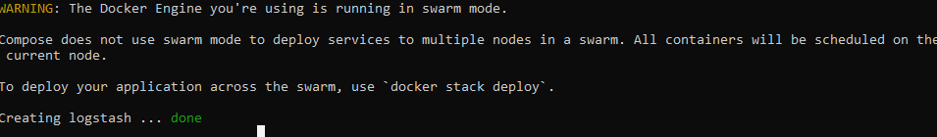

Now we have to create our configuration file and then restart this container or recreate it, let’s do that!

**Logstash configuration file**

In the beginning of article, our need is transforming Microsoft SQL data to Elasticsearch. One more step and this will be done for you. When we are creating Logstash container we also create shared volume and put “pipeline folder “into shared folder, now go to that folder. Create file inside that folder and give “logstash.conf” as name. In that file generally we have 3 section.

* Input
* Filter
* Output

**Input Section:** We define which data will transform to Elasticsearch. Also, we define driver_class, schedule etc.

**Filter Section:** If you need convert your data or filter your data by content. You can use this section.

**Output Section:** In this section you say to logstash take data from input and filter, put elsewhere (Elasticsearch another resource)

Let’s look in code

input {

jdbc {

jdbc_driver_library => ""

jdbc_driver_class => "com.microsoft.sqlserver.jdbc.SQLServerDriver"

jdbc_connection_string => "jdbc:sqlserver://mssql;databasename=TestDB"

jdbc_user => "sa"

jdbc_password => "1234"

jdbc_fetch_size => 1000

schedule => "*/45 * * * *"

lowercase_column_names => false

type=>"customer"

statement => "select * from customers"

}

}

filter {

mutate {

convert => { "Timestamp" => "string" }

}

date {

match => ["Timestamp", "ISO8601"]

target => "@timestamp"

}

}

output {

stdout {

codec => rubydebug

}

if [type] == "customer" {

elasticsearch{

hosts => ["http://elasticsearch:9200"]

index => "testdb-index-customer"

document_id => "%{CustomerId}"

}

}

}

Let’s little explain the code, in input section we start with jdbc and this represent which plugin we will use, inside that tag you see jdbc_driver_library=”” we don’t need spesifiy driver_library because we put library files when we are creating container.

Second line is “jdbc_driver_class” we specify which jdbc class we are using and then we define “jdbc_connection_string” we are writing our Microsoft SQL Server connection string after that we need username and password “jdbc_user” and “jdbc_password” code block doing that work.

Our fetch size is classic fetch size. You know fetch size is important when you transfer big amount of data. If you have 10.000 row data and your fetch size is 1000 logstash will create 10 different connection while getting data.

In schedule code block we decide which time our transform operation will run, this code block use cron job pattern, if you don’t know you can look in here <https://crontab.guru> After that you see “lowercase_column_names” using this code block you can specialize your columns name transformation. We are using “type” code because when we have multiple jdbc input and if we want specialize each input’s output by one by one, you can use this code block and in output section you can use “if” block and separate to output. Last code block in jdbc section is “statement” you can write your sql queries here.

In filter code block we see two section. In my customer table I have “Timestamp” column and this area type is Datetime. First I convert this area to string and then taking this string area and converting date using “ISO8601" standard and put this area to “@timestamp” area. Why I am doing this, because I don’t want to use default Elasticsearch @timestamp and overwriting my “Timestamp” area.

Let’s come our final code block “output” We take our data in input, we put some filter on in filter section and now we have to write our data elsewhere. In stdout section actually write data to console. You can look details in here <https://www.elastic.co/guide/en/logstash/7.3/plugins-outputs-stdout.html>

Ooo we see type, remember we just talked. If our type customer use Elasticsearch. If you create another jdbc code block and if you want it transform to different way, you can use like this. I am saying that something like thisin here.

If my type “customer”, use “elasticsearch” and this “elasticsearch” hosts are ["http://elasticsearch:9200"] in here, data index will be “testdb-index-customer” and document_id will be our “CustomerId” column which represent like this in code block "%{CustomerId}"

Let’s look our results 😊

**RESULTS**

After put our logstash.conf file in pipeline folder. We need restart our container. You can use these commands:

docker-compose -f logstash-compose.yml down

docker-compose -f logstash-compose.yml up -d

If you want follow logs don’t use -d keyword in docker-compose up command. If you miss this step, look your container name and write this command:

docker container logs <container-name> --follow

If your transform success you should see in your console screen something like this.

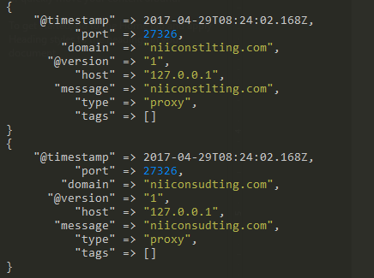

# References

Elasticsearch, C., 2019. *https://www.elastic.co.* [Online]   
Available at: https://www.elastic.co/guide/en/logstash/current/plugins-filters-jdbc_streaming.html  
[Accessed 28 09 2019].

Elasticsearch, C., 2019. *https://www.elastic.co.* [Online]   
Available at: https://www.elastic.co/guide/en/logstash/current/plugins-filters-aggregate.html  
[Accessed 28 09 2019].

Elasticsearch, C., 2019. *https://www.elastic.co.* [Online]   
Available at: https://www.elastic.co/guide/en/logstash/current/plugins-filters-translate.html  
[Accessed 28 09 2019].

Elasticsearch, C., 2019. *https://www.elastic.co.* [Online]   
Available at: https://www.elastic.co/guide/en/logstash/current/plugins-inputs-jdbc.html  
[Accessed 28 09 2019].

Elasticsearch, C., 2019. *www.elastic.co.* [Online]   
Available at: https://www.elastic.co/what-is/elasticsearch  
[Accessed 21 09 2019].

Elasticsearch, C., 2019. *www.elastic.co.* [Online]   
Available at: https://www.elastic.co/products/logstash  
[Accessed 21 09 2019].

Opensource, 2019. *opensource.com.* [Online]   
Available at: https://opensource.com/resources/what-docker  
[Accessed 21 09 2019].

Rouse, M., 2019. *searchsqlserver.techtarget.com.* [Online]   
Available at: https://searchsqlserver.techtarget.com/definition/SQL-Server  
[Accessed 21 09 2019].

Simic, S., 2018. *phoenixnap.com.* [Online]   
Available at: https://phoenixnap.com/kb/how-to-install-docker-on-ubuntu-18-04  
[Accessed 22 09 2019].

**This article supports Open-Article project.**

Open article means, you can get these articles and convert them into your needs. If you see misspelling on articles, you can contribute to here or you can translate in your language. You can write your article and put our community.

<https://github.com/organizations/Open-Article>